Project: Object/Image Recognition using Convolutional Neural Network (CNN).

Data Exploration, Verification and Standardization

Summary url:

Ref
1) https://www.anaconda.com/
2) http://yann.lecun.com/exdb/mnist/
3) https://www.python.org/
4) https://www.tensorflow.org/tutorials/estimators/cnn

For this experiment - the purpose is to use the NIST dataset and process those images using toolsets Python (on jupyter) and TensorFlow/Keras.

Data Discovery will be to visualize and verify the MNIST dataset. Data Cleansing steps normally used to prepare the dataset will also be included as necessary; these steps are to standardize, impute, dimensional reductions, etc. It is assumed that the dataset will not need Data Cleansing other than verifying the formats.

The MNIST Dataset - Source
When using the function urllib.request.urlretrieve() I downloaded the four files in their gzip compression.

doing a shape check on Ref(2) raw training data
> train_images.shape
(60000, 28, 28, 1)

Using TensorFlow (TF) utility functions, I was able to drop the four files supplied with TF. These files are the same size as those found on ref(2). After downloading the four files (training data/labels and testing data/labels); the raw format/shape of each file is array.
Shape Check
The training dataset is (60000, 748)
The test dataset is (10000, 748)

It is noteworthy to understand that although it’s the same data - the formats could be different. Depending on what library is used - these formats may need to be modified to suit.

The MNIST Dataset - Data Discovery
The MNIST problem is a dataset developed by Yann LeCun, Corinna Cortes and Christopher Burges for evaluating machine learning models on the handwritten digit classification problem.

The dataset was constructed from a number of scanned document dataset available from the National Institute of Standards and Technology (NIST). This is where the name for the dataset comes from, as the Modified NIST or MNIST dataset.

Dataset of Images
Images of digits were taken from a variety of scanned documents, normalized in size and centered. This makes it an excellent dataset for evaluating models, allowing the developer to focus on the machine learning with very little data cleaning or preparation required.

Each image is a 28 by 28 pixel square (784 pixels total), see fig(1). A split of the dataset is used to evaluate and compare models, where 60,000 images are used to train a model and a separate set of 10,000 images are used to test it.

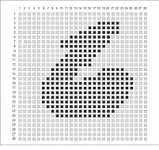
fig(1) - typical image of digit

The preparation of the data includes a "flattening" of the image. This means the 28x28 array of pixels are converted to a flat 1-D structure of 784 (28 * 28) raw pixel values, see fig(2).
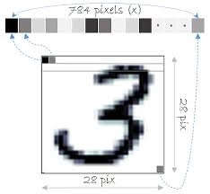
fig(2) 28x28 array converted into 1x784 array

The Training Dataset
The Training dataset has 60000 records/instances (1x784 size); each record representing one image.

